**Docker:**

As a developer, we will do the coding and create the web application. Then once we developed it completely & run it successfully, we have to give it to the testing team & then devops team to deploy it.

But our app has various configurations like websever, DB & many others.

Other teams can’t do all these configurations one by one. Even then it will be complex and create multiple errors.

To solve this issue, docker was introduced. With docker, we can share our project with anyone with all the configurations.

Before Docker, Virtualisation and containerization was used.

**Virtualisation**:

VM means Virtual machine(Hypervisor)

To share ur app, u will create ur app in a host OS and share that host OS itself to other teams. It takes lot of CPU memory and RAM.

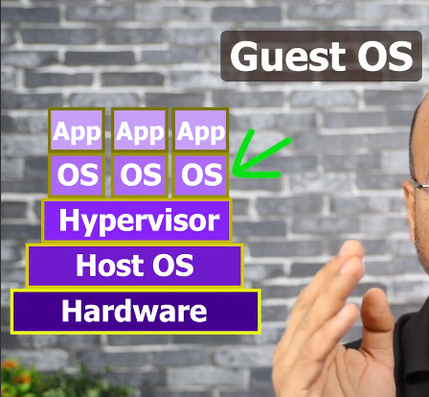

**Containerization**:

Think of Shipping industry. U will port the things in a container. Same like that, here we will share our app in a container. Container is a software. Container has all the configuartions with itself. Many softwares are there for Containerization but Docker is one of the most famous one.

**Docker:**

Docker is a platform/software which has a set of tools to run the containers.

Containers: manages the containers

Images: Docker file which has the info of app which help others to implement it in their machine. Docker hub has all the images for us.

Volume: storage of docker